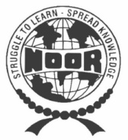 | Noor College  of Professional Education

Noor Education Service was established more than 32 Years ago on 21st March 1947, with the aim to develop comprehensive training programs to bridge the existing gap between formal education system and the realistic modern technological skill requirement of the business world.
NCPE is currently conducting training in the field of Commerce, Computer Science and English Language. Ncpe, pursuant to rigorous requirements of professional world, prepares students for entry to the most prestigious and professional organization in pakistan.

RAMADAN SPECIAL PAKAGE
One – Month Crash Program
O f f i c e A u t o m a t i o n I n t r o d u c t i o n
Microsoft Office XP
- Analyzing data using MS EXCEL
- Creating documents in MS WORD
- Making Electronic Presentation using PowerPoint

Bussiness Recorder Road, Garden East, Near Gurumandir, Karachi
Phone: 2251034 – 2256161, Fax: 2230931
Website: www.ncpe.edu.pk, E-mail: info@ncpe.edu.pk

