Qantas Airways Sprit of Australia
. .
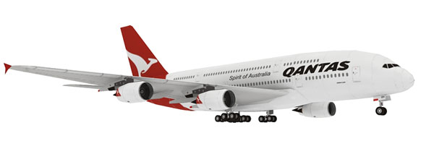
Qantas Airways Limited Is The Flag Carrier Of Australia. The Name Was Originally “Qantas”, An Acronym For “Queensland And Northen Territory Aerial Service”. Nicknamed “The Flying Kangroo”, The Airline Is Based In Sydney, With Its Main Hub At Sydney Airport. It Is Australia’s Largest Airline In The World And The Second Oldest In The World Overall.Qantas Headquarter Are Located In The Qantas Centre In The Mascot Suburb Of The City Of Botany Bay, Sydney, New South Wales.
Currently The Airlines Is Considered A Four-Star Airline By Research Consultancy Firm Skytrax In 2011, Qantas Was Voted The Eighth Best Airline In The World By The Firm , A Drop From 2010(Seventh), 2009 Qantas Still Retains A 65 Percent Share Of The Australian Domestic Market And Carries 18.7% Of All Passengers Travelling In And Out Of Australia.

History
Qantas Was Founded In Winton, Queensland On 16 November 1920 As Queensland And Northern Territory Aerial Service Limited. The Airline’s First Was An Avro 504k.The Airline Flew Internationally From May 1935, When It Commenced Service From Darwin To Singapore. In June 1959 Qantas Entered The Jet Age When The First Boeing 707-138 Was Delivered.

Headquarters
Qantas Headquarters Are Located In The Qantas Centre In The Mascot Subrub Of The City Of Botony Bay,Sydney,New South Wales.
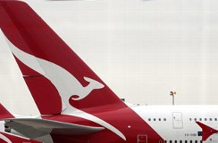
In 1920 Queensland And Northen Territory Aerial Ltd Had Its Headquarters In Winton, Queensland. In 1921 The Head Office Moved To Longreach,Queensland.In 1930 The Head Office Moved To Brisbane. In 1957 A Head Office, Qantas House, Opened Along Hunter Street In Sydney, In The 1970s A New A$50 Million Headquarters, Consisting Of Twin Skyscrapers, Was Being Built In Sydney And Expected To Take One City Block. The First And Largest Tower Had An Expected Completion Time In 1973.
. .
© Qantas Airways Limited

