Nokia Lumia 620
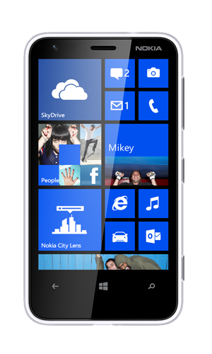

The Nokia Lumia620 is a smartphone designed, developed and marketed by Nokia. It is the successor to the Lumia 610, and is one of the first Nokia phones to implement Windows Phone 8 alongside the Nokia Lumia 920 and Nokia Lumia 820. Although sharing a similar name with the Lumia 610, the Lumia 620 is a major overhaul over its predecessor, employing a 1.0 GHz dual-core processor. It was announced in December 2012 and started selling in January 2013 in Asia, followed by Europe and the Middle East at an estimated street price of USD 249. In the United States, the Nokia Lumia 620 is available for AT&T's subsidiary brand Aio Wireless.
Like other Lumia devices with Windows Phone 8, Nokia adds these applications: Nokia Drive, Nokia Maps, Nokia City Lens, Nokia Music(select marketSmartshoot, Cinemagraph.
Because of the limited memory available on this phone, certain applications and features will not be able to run.
ReceptionEngadget reviewed the phone very positively. It praised its battery life, performance, and value for money. It noted that the camera was not very good, but okay considering that the 620 is a budget phone.
James Rogerson of TechRadar in his review wrote: "There's not a whole lot that the Nokia Lumia 620 does wrong.As an all-round, jack of all trades budget handset it does a great job.We'd love it if the screen
was lightly bigger or it had a little bit more RAM,but for the price we can't really complain. The onlyrealis the battery, and that's an issue to some extent withevery Windows Phone 8 right now."
Specification
- MANUFACTURER
Nokia

- SERIES
Lumia

- PREDECESSOR
Nokia Lumia 610

- TYPE
Smartphone

- WEIGHT
127 g (4.5 oz)

- OPERATING SYSTEM
Windows Phone 8

- MEMORY
8 GB internal flash
512 MB RAM

- REMOVABLE STORAGE
MicroSD (up to 64 GB)

- BATTERY
Removable/Rechargeable BL-4J 1300 mAh

- FRONT CAMERA
VGA, 640×480 pixels

- DISPLAY
3.8" LCD ClearBlack capacitive touchscreen
800×480 px 16.7m-color

- CONNECTIVITY
3.5mm headset jack, USB 2.0, Bluetooth
3.0,802.11a/b/g/n,NFCA-GPS,GLONASS

