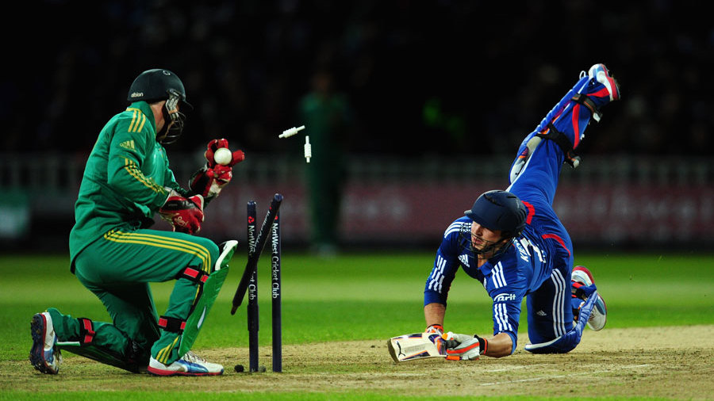

SOUTH AFRICA TOUR OF ENGLAND 2012
DATE | DAY | MATCH | PLACE
Jul 19 | Thursday | 1st TEST | Kennington Oval, London
Aug 2 | Thursday | 2nd TEST | Headingley, Leeds
Aug 16 | Thursday | 3rd TEST | Lords, London
Aug 24 | Friday | 1st ODI | Sophia Gardens, Cardiff
Aug 28 | Tuesday | 2nd ODI | The Rose Bowl, Southampton
Aug 31 | Friday | 3rd ODI | Kennington Oval, London
Sep 2 | Sunday | 4th ODI | Lords, London
Sep 5 | Wednesday | 5th ODI | Trent Bridge, Nottingham
Sep 8 | Saturday | 1st T20 | Riverside Ground, Chester le Street
Sep 10 | Monday | 2nd T20 | Old Trafford, Manchester
Sep 12 | Wednesday | 3rd T20 | Edgbaston, Birmingham

