Serial Number: Batch Code:
1002
Aug, 2013
Noor College
of Professional Education
Certificate
Muhammad Haris
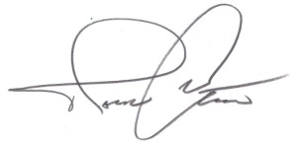
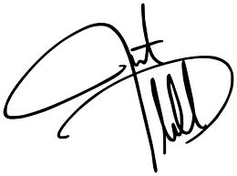
This is to Certify that _________________
has successfully completed the prescribed course for
Diploma in _____________________________ as a regular student
from ____________ to ___________
He / She has been examined and found qualified to
receive this certificate and is placed in Grade _________
C I T (Certificate In Information Technology)
A
November, 2013
August, 2013
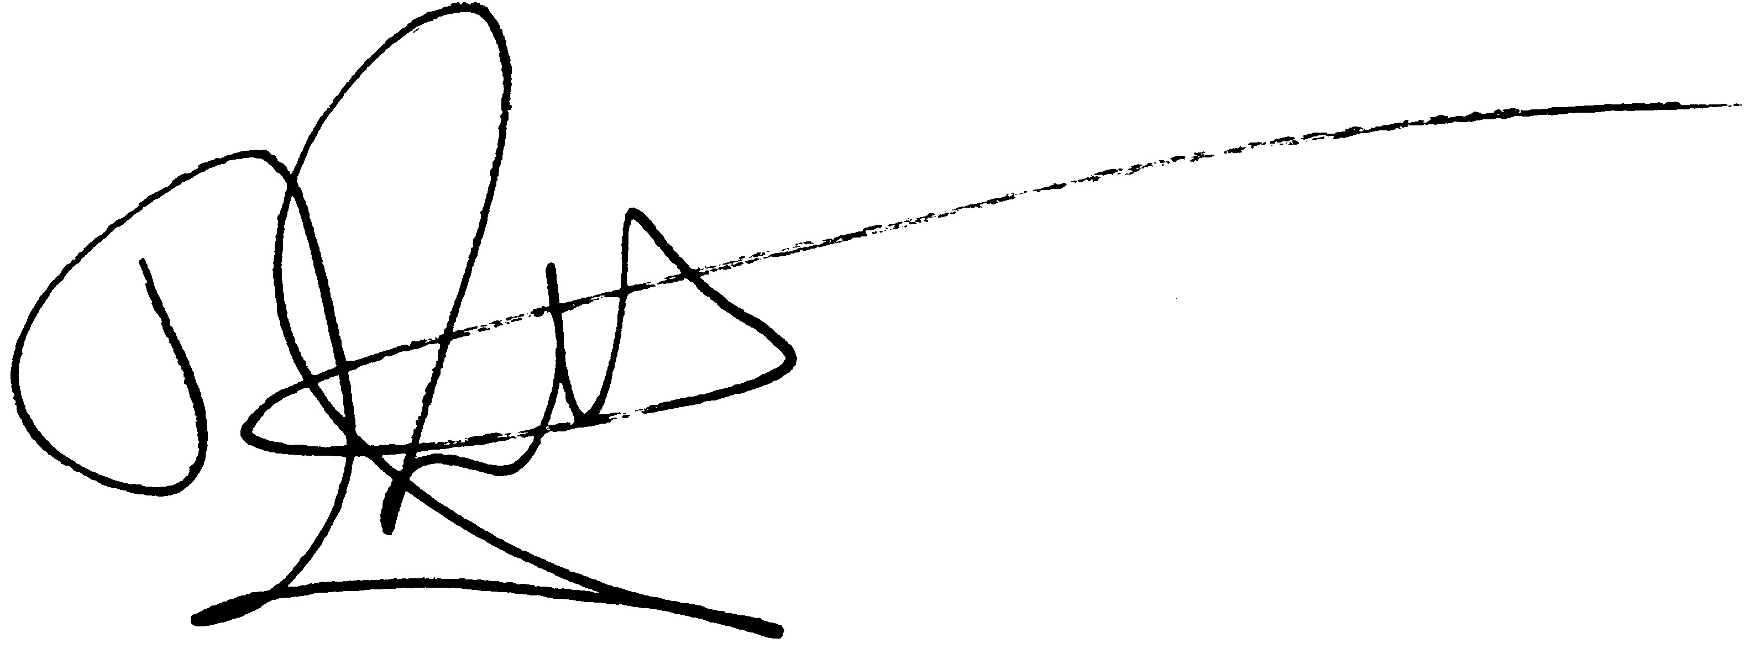
Program Manager Administrator Director

